LAB 01:
1. Write a program that take input of your roll number along with the marks obtained
in five subjects and display the total marks obtained and the percentage.
CODE:
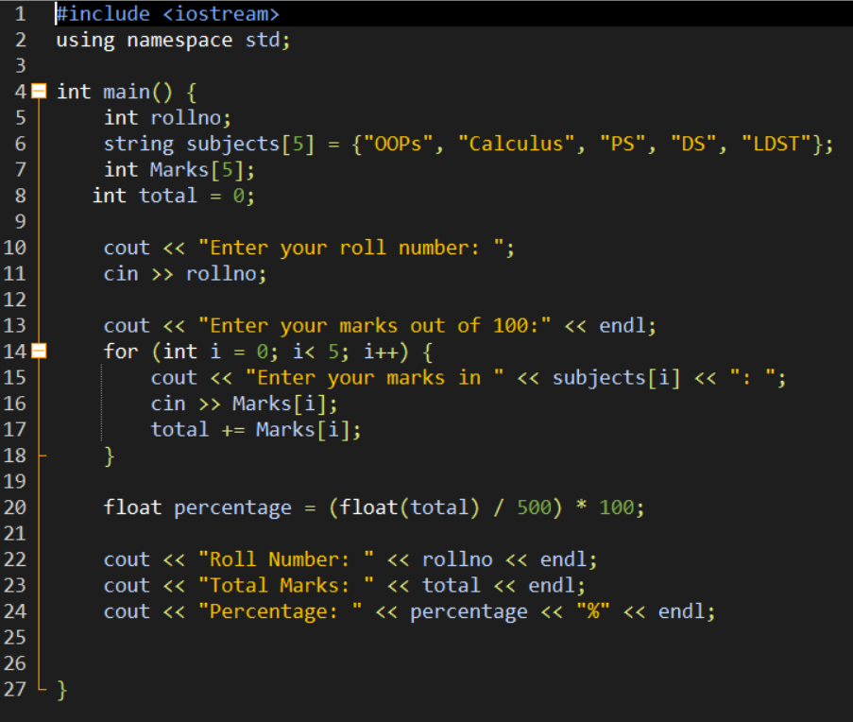
OUTPUT:
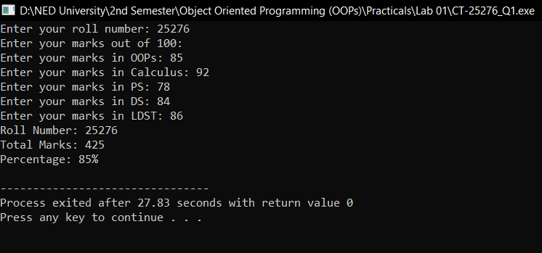
2. Write a program to swap three numbers entered by a user using pointers.
CODE:
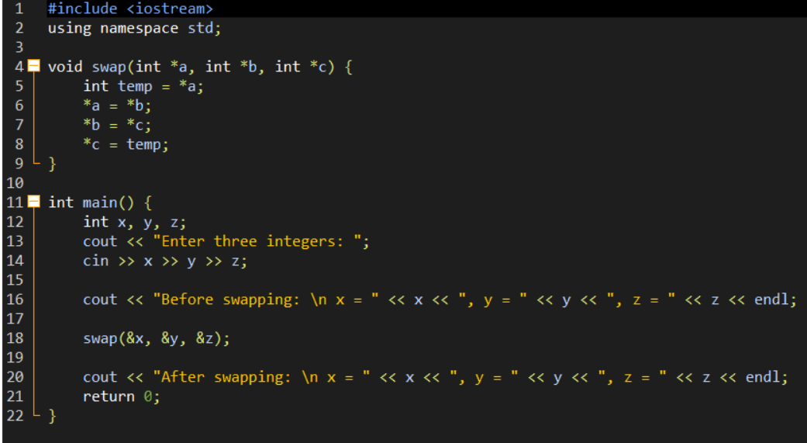
OUTPUT:
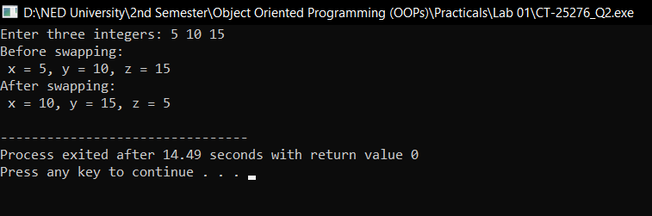

3. Write a program to convert temp from Fahrenheit to Celsius unit using equation
(C=(F-32)/1.8).
CODE:
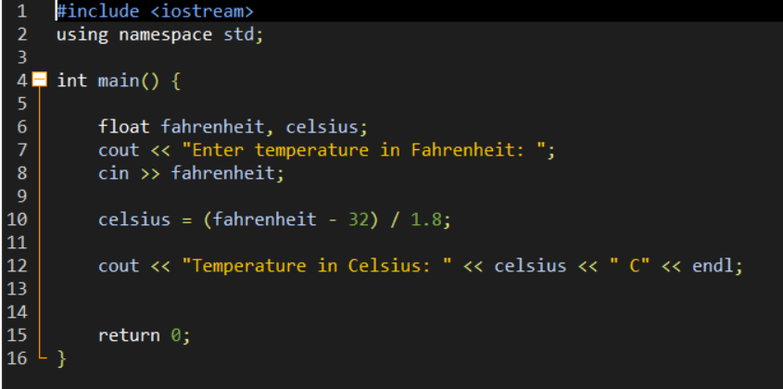
OUTPUT:
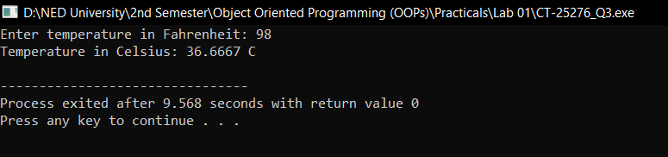

4. Using 2-D arrays, write a program that allows the user to input two, 3x3 matrices.
Write a function for adding two matrices. Write another function for multiplying
the two matrices.
CODE:
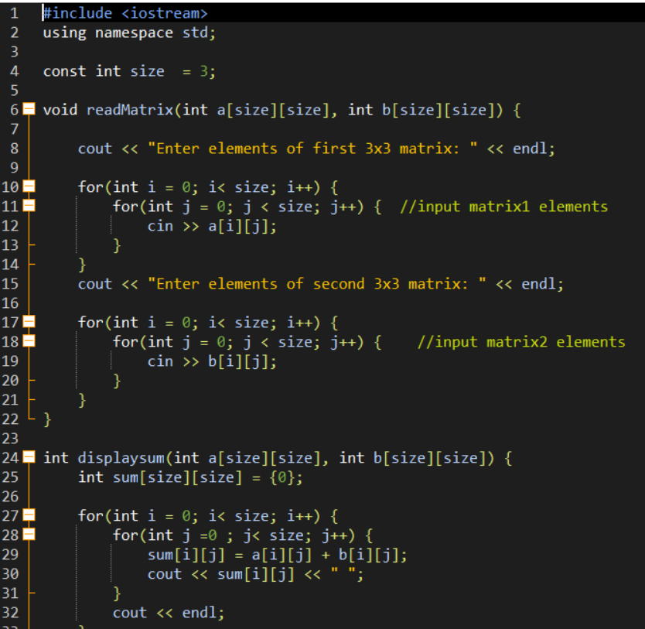
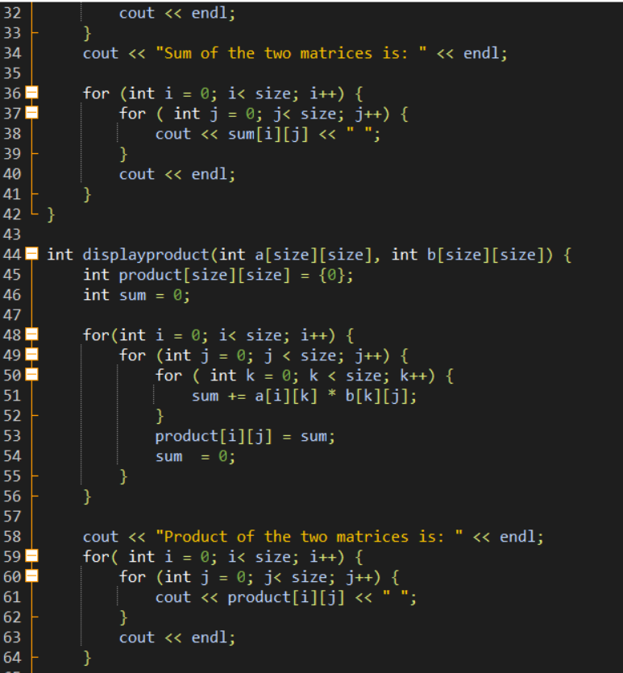
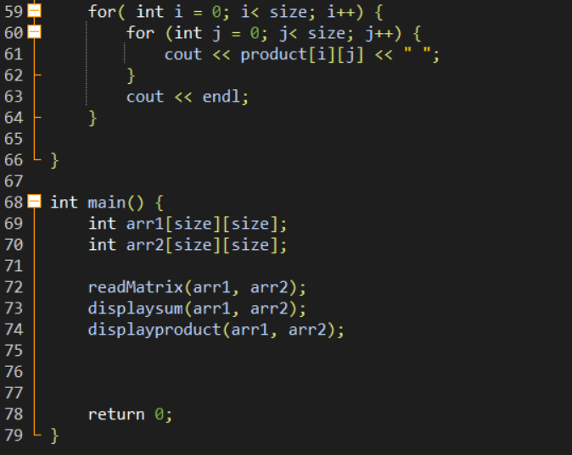
OUTPUT:
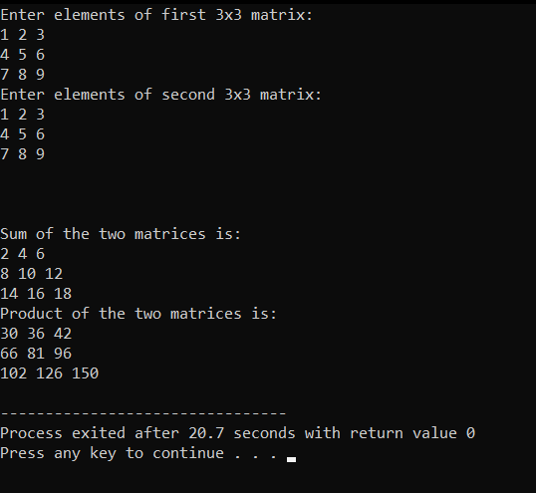
5. Write a program to find Surface area and volume of a sphere using functions.
CODE:
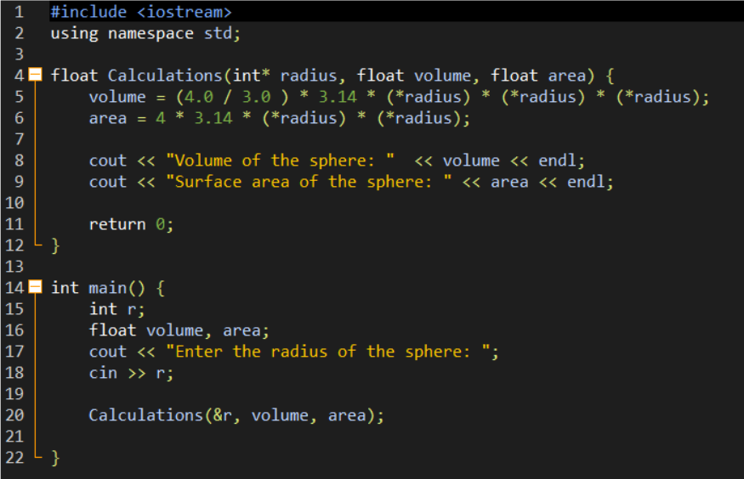
OUTPUT:
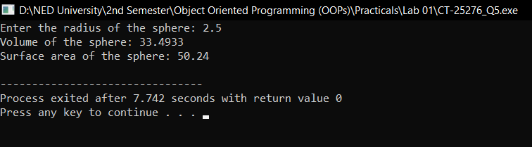

6. Write a program to help a bank create its withdrawal system. Your program should
allow the user to input their account type. Account types are: savings, current.
Following business rules apply when withdrawing from a certain account:
1. Savings:
- User must provide the savings account number and code ‘S’ (for savings).
When withdrawing from a savings account, users need to pay a set 2% of
the money that they withdraw. If the amount of money withdrawn is over
50,000, then a 5% tax will be deducted. The money deducted shall be from
the remaining money in the account.
2. Current:
- User must provide the current account number and code „C‟ (for current).
When withdrawing from a current account, users need to pay a withdrawal
fee of 100. If the amount of money withdrawn is over 50,000, then a 5% tax
will be deducted. The money deducted shall be from the remaining money
in the account.
Assume all users have the 200,000 in their accounts, and cannot withdraw more
than 100,000 at a time.

CODE:
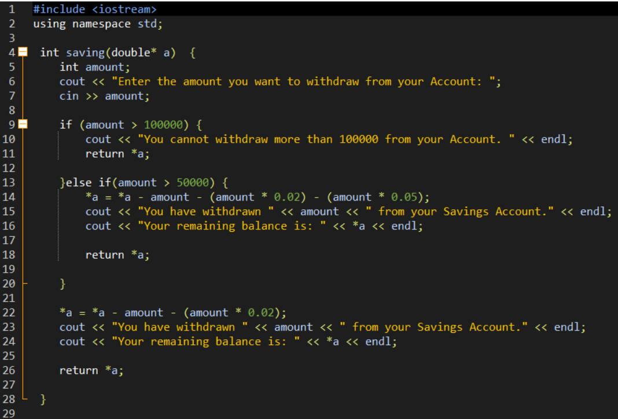
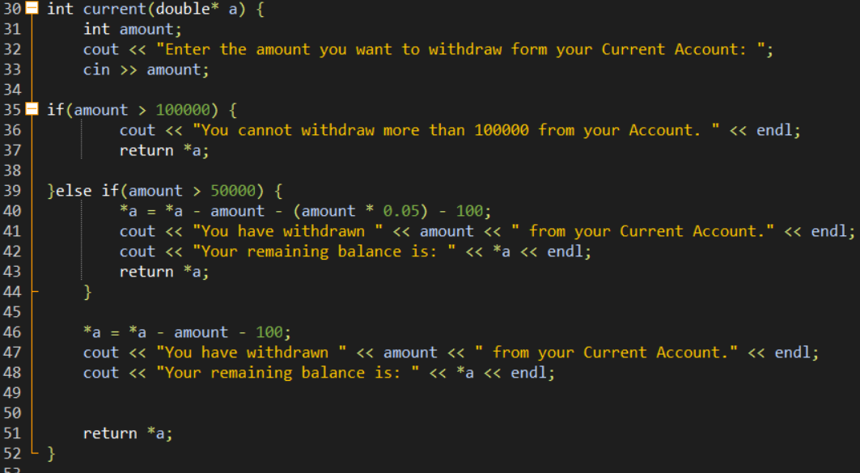
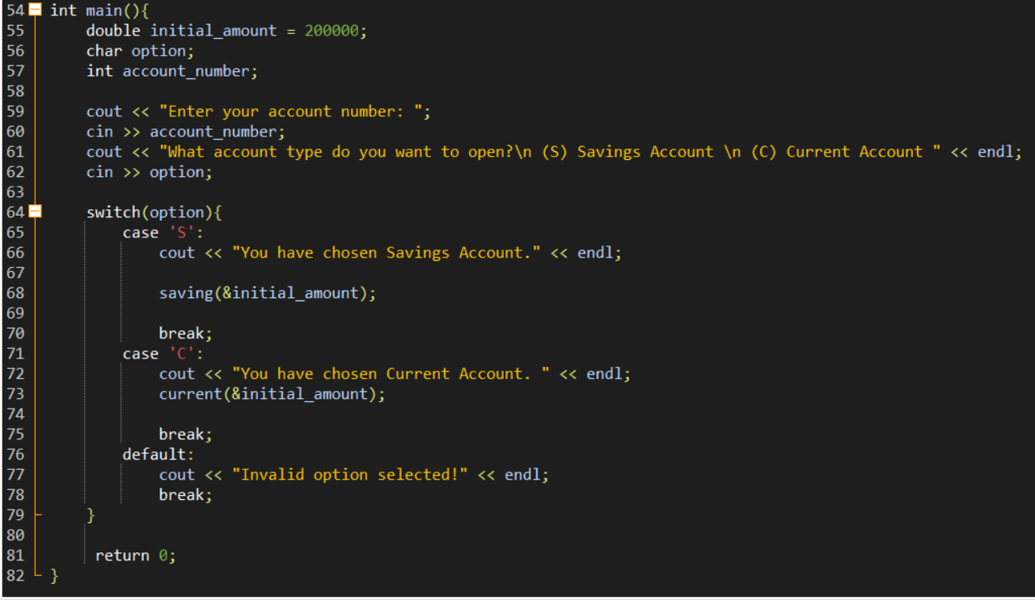

OUTPUT:
